**CSS**

Syntax

/* syntax */

/* selector{

    property1: value1;

    property2:value2;

} */

**Selector Types**

/* element Selector */

body{

    background-color: aqua;

}

P{

    background-color: brown;

}

/* id Selector */

#FirstPara{

    background-color: rgb(0, 26, 255);

}

/* class selector  */

.MyFirstDivClass{

    color: white;

}

Margin

Padding

CSS Box Model

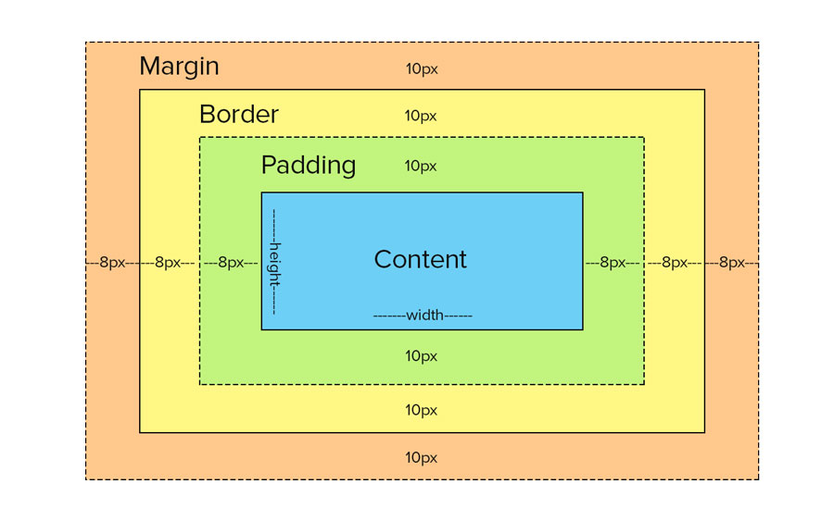

Text formatting & Text Decoration

#TextFormatingPara{

    color: antiquewhite;

    text-align: center;

    text-decoration: none;

    font-size: 16px;

}

/* text Decoration */

.MyFirstDivClass a{

    text-decoration: none;

    text-transform: uppercase;

    letter-spacing: 3px;

}

a:hover{

    font-size: large;

    color: chartreuse;

}

**Em,px,rem,%,px**

rem adjust according to html parent

em adjust according to its parent

vh is height and vw is width of window

.PararememEg{

    background-color: cornflowerblue;

    text-align: center;

    font-size: 10px;

}

#Para1{

    font-size: 6em;

}

#para2{

    font-size: 2vw;

}

1em=16px

**Positions**

**Absolute** – element will arrange according to its parent

**Relative** – element will move according to their position and will leave the gap in its position

Static – This is the default position

**Fix**- If we want to fix element and after scrolling this wont scroll in such kind of req

**Stickey**- menu sticky bar eg. It sticks to window event if you scroll

**FlextBox**

.flexeg > div{

    height: 50px;

    width: 50px;

    background-color: darkred;

    margin: 2px;

}

.flexeg{

    display: flex;

    flex-direction: row;

    flex-wrap: wrap;

    justify-content: center;

    background-color: coral;

    height: 150px;

    align-items: center;

}